**The Role of Student Wellbeing Center in Promoting Students’ Wellbeing and Resilience: The Case of International Balkan University**

**Fatime Ziberi[1]**

**Sonaj Bilal[2]**

**Katerina Mitevska Petrusheva[3]**

In recent years, the well-being of students has become a significant area of interest for many scholars, educators, psychologists and other professionals due to the contemporary trends in education that prioritize a student-centered approach, where, in addition to the study curriculum, special importance is also given to the needs of the students and their well-being. Educational institutions aim not only to impart knowledge and skills, but also to provide supportive and adaptive environment where students feel accepted and valued, since they spend a very significant amount of their time within university settings.

The dynamic lifestyle and the pressure of academic responsibilities, including exams, often lead to stress and anxiety among students. The inability of students to deal with external stressors in a healthy way affects their well-being and all this undoubtedly affects academic performance and success. Numerous studies report on the connection between these two factors, emphasizing once again the importance of enhancing psychological well-being. For many students the process of adaptation is very stressful in itself, especially for the students studying abroad, who also encounter language and cultural barriers, as well as financial challenges, which further increase their stress levels.

A previously conducted research at International Balkan University, focusing on student resilience and wellbeing revealed that students have a moderate level of well- being, with the highest score in Personal growth and the lowest in Positive relations with others. Based on these findings, recommendations for improvement were given, regarding four main aspects: Curriculum interventions, Leisure activities, Social activities and Counseling services (Mitevska Petrusheva & Ziberi, 2023). In response, policies were implemented and the Student Well-being Centre (SWC) was established at IBU. This paper will present the structure, services, and activities of SWC. This initiative can offer valuable insights and recommendations for school counselors and educational institutions aiming to enhance student well-being.

The establishment of SWC which provides psychological counseling services and organizes numerous social activities and events where the students are actively engaged, has already contributed to improving social relationships among students and the overall atmosphere on campus.

Keywords: well-being, resilience, student

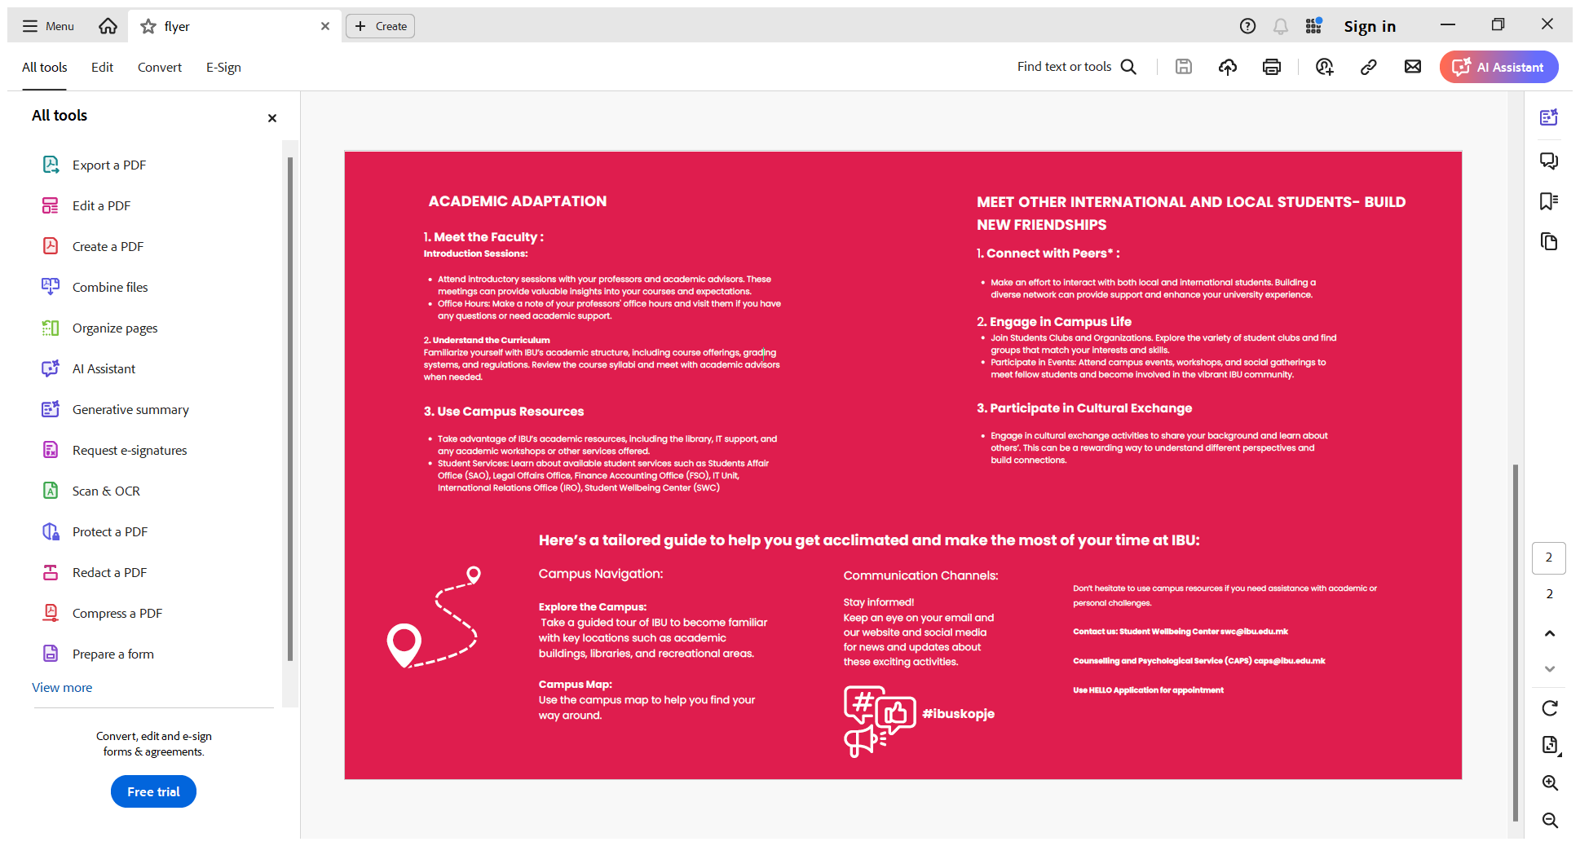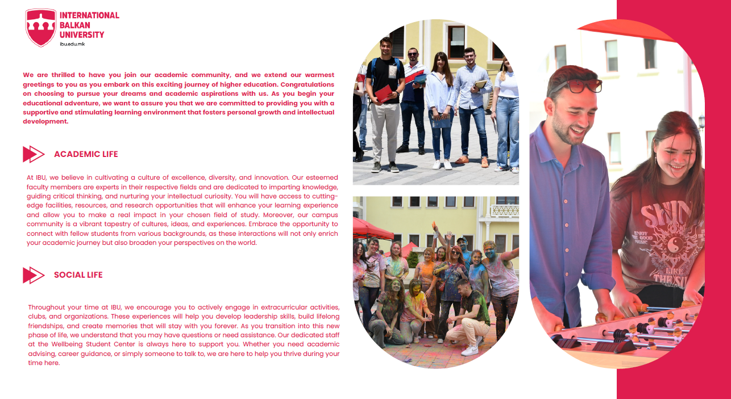

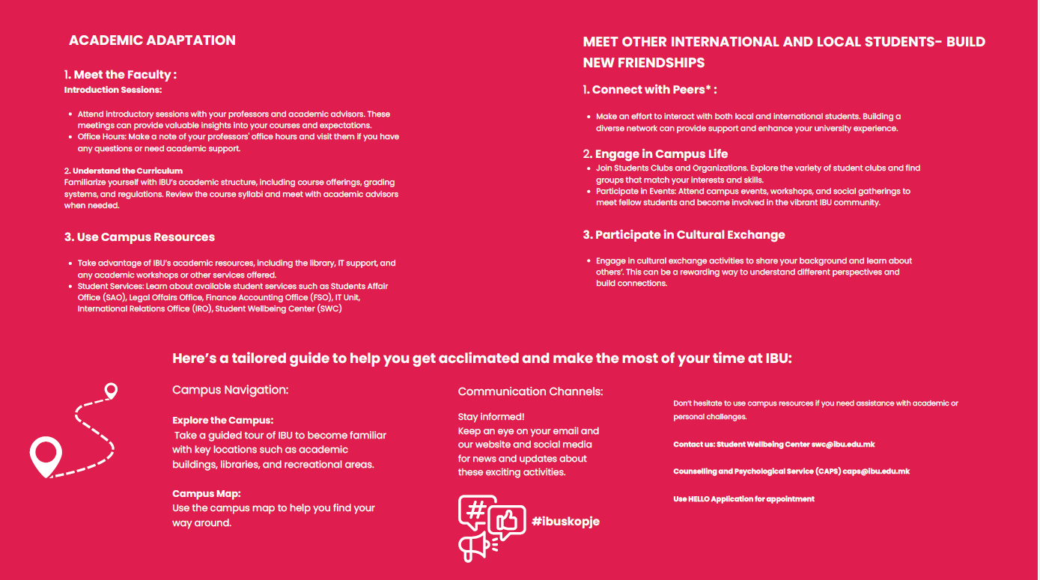

1. PhD Candidate Psychology, Department Psychological Counseling and Guidance, Faculty of Education, International Balkan University (IBU), Skopje, Orchid ORCID: 0000-0002-4715-8601, email: [f.ziberi@ibu.edu.mk](mailto:f.ziberi@ibu.edu.mk)

   Phone: 0038970910435
2. Teaching Assistant, Department Psychological Counseling and Guidance, Faculty of Education, International Balkan University (IBU), Skopje, ORCID: 0009-0001-3000-3136, email: [sonaj.bilal@ibu.edu.mk](mailto:sonaj.bilal@ibu.edu.mk)
3. Assoc. Prof. Department Psychological Counseling and Guidance, Faculty of Education, International Balkan University (IBU), Skopje, ORCID: 0000-0002-7007-7340, email: [katerinam.petrusheva@ibu.edu.mk](mailto:katerinam.petrusheva@ibu.edu.mk)